University of Leeds

ELEC5032M - Modern Industry Practice

Phase 2 Draft

Group 27

2024/25

**201715540**

**201777135**

**201388759**

**201716692**

# Phase 2

## 2.1 Introduction of the Project

**2.1.1 Selected Technology and its Importance (201777135)**

As part of Phase 2, we focus on two significant technologies to achieve our goals in Zero Hunger (SDG2), Good Health and Well-Being (SDG3), and Reduced Inequalities (SDG10). To clearly display our project framework and makes sense, I will show a diagram below which explains specific technologies included in the project, the advantages offered, and the connection with the Sustainable Development Goals.

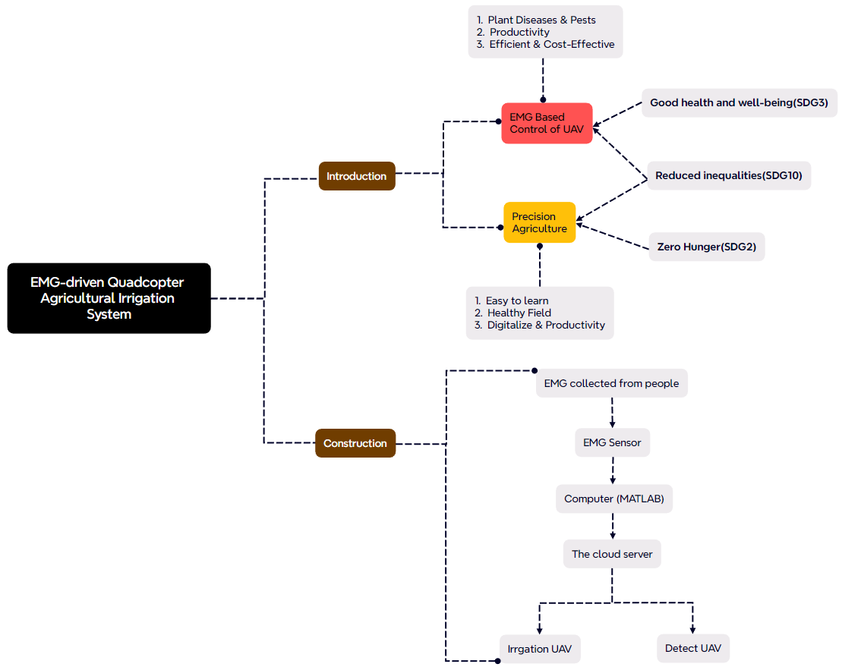

Figure 1 A block diagram of EMG-driven Quadcopter

The first technology is the application of UAV in precision agriculture, which plays an important role in achieving Zero Hunger (SDG2) and really potential in the future. Nowadays, most of developing countries need to improve the crop productivity. For example, over 70% people are living by farming in India[1]. However, conventional agricultural methods fall short due to challenges like plant diseases and pests, underscoring the divide between developed and developing countries. To reduce such inequality(SDG10), we can use relative technology in the precision farming which is more helpful and benefitial for productivity. For example, sensing technology is widely used in the last 35 years.[2] Recently, precision agriculture has improved a lot which is estimated to reach $43.4 billion by 2025. [3] There has been an uptick in worldwide enthusiasm for Precision Agriculture as a key strategy to address the growing requirement for enhancing the production of food and energy with superior qualities, aiming for greater sustainability and reducing negative external effects.[4] Using remote sensing technology, precision agriculture can be implemented based on pre-existing maps of targeted variables. Remote sensing offers an efficient and cost-effective method for farmers to collect data, visualize, and analyze the condition of crops and soil throughout various stages of the growth cycle.[5]

The second one is the EMG Based Control of UAV (Unmanned Aerial Vehicle)  which is a simple and effective way to permit not only amateur users but also some disabled people to control the UAV. Research conducted in 2017 made use of an EMG sensor to manipulate unmanned aerial vehicles, monitoring a quadcopter of launching and landing , harnessing the native signals from the sensor, which featured eight electrodes.[6] Besides, The field of health benefits significantly from EMG technology. Prompt diagnosis is essential and of great importance in medical practices. By comparing the health profiles of individuals who are healthy with those who are not, it becomes possible to facilitate the early detection of not only Alzheimer's disease but also Parkinson’s disease.[7-8] In this way, it's also helpful to achieve our goals of Good Health and Well-Being (SDG3) and Reduced Inequalities (SDG10). Electromyography (EMG) signals have been employed for 30 years to monitor the hand motions of humans, significantly aiding in the management of prosthetic hands [9]. This method offers considerable advantages, particularly for persons with disabilities, by leveraging EMG signals. Therefore, we want to use the EMG to control the drone which is simple and easy, even disabled people can learn it quickly. Based on the application of UAV in agriculture, it's also important for crop productivity.

**2.1.2 The Importance and Applications for disabled (201716692)**

In order to realize social equity and promote economic development, promoting the employment of persons with disabilities is a necessary way. First, according to the data of China Disabled Persons' Federation, the total number of disabled people in China has exceeded 85 million in 2018, distributed in 260 million families, of which about 32 million people are at the age suitable for employment, but only 9,484,000 people with disabilities in China are involved in employment, which accounts for only 29.6% of the total number of people with disabilities [10].

Second, in the traditional values of the United States, "equality" means equal opportunity, not equal results, and the U.S. government encourages individuals to work hard to improve their own situation, including people with disabilities [11]. At the same time, American society generally recognizes that people with disabilities have the same civil rights and employment opportunities. The U.S. government and society will also support their full participation in the labor force [12].

Overall, promoting the employment of people with disabilities can lead to a large workforce, thus achieving social justice.

Figure 2 Disability Prevalence in the General Population and Employment Rates Among Persons with Disabilities of Working Age

In order to improve the employment of people with disabilities, our team provides a method to control drones using electromechanical signals to enable them to perform agricultural irrigation. Nowadays electromechanical control is becoming more and more common in robotics as a muscle-computer interaction technique. Among them, electromyography (EMD) is widely used in biomedicine, prosthetics, and human-machine interfaces as a non-invasive and indirect brain-computer interface technology. However, there is also a problem that there is noise in EMD signals, which can affect the efficiency of human-computer interface [13].

In order to control the unmanned aerial vehicle (NAV), our team proposes systems such as Microsoft Kinect, which can help to realize the vision-based gesture recognition function [14]. This feature, which is easy to implement for hardware integration and fast processing of movements globally, has many advantages. However for controlling mobile robots, our team advocates Inertial Measurement Units (IMUs) and EMG systems that are both proven to be very effective [15]

For the capture of muscle activity, EMG is not only very effective, but it can also be converted into specific designated signals for electronic devices. Thus, EMG can output electrical signals based on muscle contraction and relaxation. In this case, using the signals from the shoulder muscles, which are processed, classified and collected in the prosthetic control system, the control of the device by EMG signals can be realized, and this technique is widely used in the field of prosthetics [17].

## 2.2 System Block Diagrams

**2.2.1 Overall Block Diagram (201715540)**

Figure 3 The overall block diagram of the EMG-driven Quadcopter Agricultural Irrigation System (201715540)

### 2.2.2 Block Diagram of EMG (201715540)

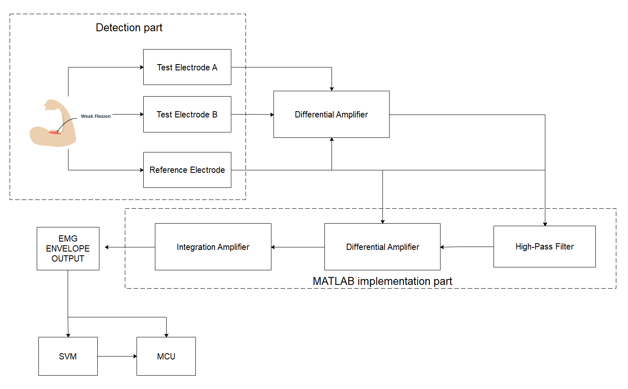

Figure 4 The Block diagram of EMG subsystem.( 201715540)

### 2.2.3 Block Diagram of UAV(201388759)

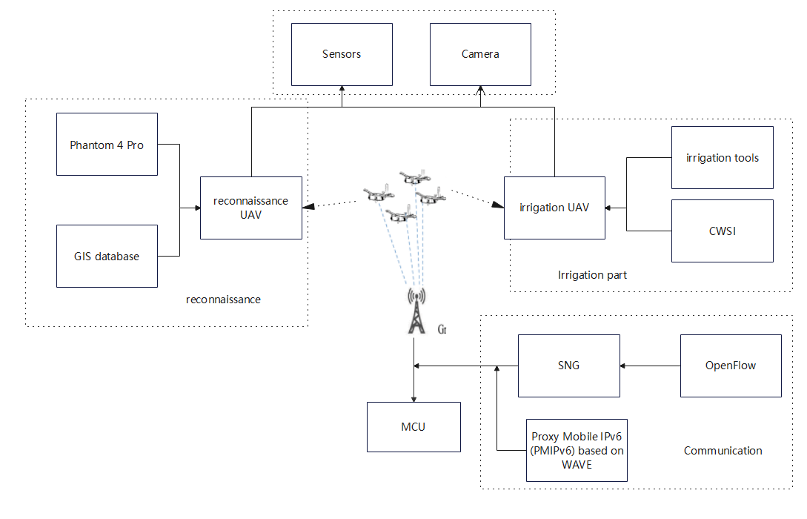

Figure 5 Block Diagram of UAV. (201388759)

## 2.3 System Explanation (201715540 and 201388759)

### 2.3.1 Aim of the System (201715540)

The aim of this system is to solve the problem that many of the disabled people cannot have ability to choose diverse jobs and allowing people with disabilities to shine in more fields and reducing inequality (as discussed in section 2.1). As drone AI and EMG sensors develop, improving and upgrading jobs for people with disabilities becomes increasingly urgent.

### 2.3.2 Function of the System (201388759)

The principle of this system is sending the EMG signal to server, after processing by the server the server will send instruction to the UAVs. The UAVs are divided into detect UAV and irrigation UAV, which can respond accordingly according to the instructions. The Detect UAV will also feedback data to the server for processing when it performs its own inspections.

As shown in the figure below, it is represented to a service site. The right side represents the drone operating area, and the left side represents the central base station for data transmission and processing. They are connected to the server through signal towers. The muscle sensor transmits myoelectric signals to the server. Moreover, the server commands the Detect UAV to start data monitoring and return after processing. After processing by the server, it transmits the signal to the irrigation UAV to perform irrigation operations. Finally, the entire complete system is formed.

Figure 6 Function of the System (201388759)

### 2.3.3 Function of Main System Blocks (201715540 and 201388759)

#### 2.3.3.1 Function of EMG (201715540)

To achieve the function of the EMG system module, the most important thing is know how to extract the surface electromyogram signal of the muscle group and identify the signal. When using the Compound carbon aerogel electrode (2 test electrodes, 1 reference electrode) get the SEMG from the muscle group, the test electrodes will transmit the signal to amplifier. The differential amplifier is used to reduce the common noise signal of two electrodes and amplify the difference of these two signals.

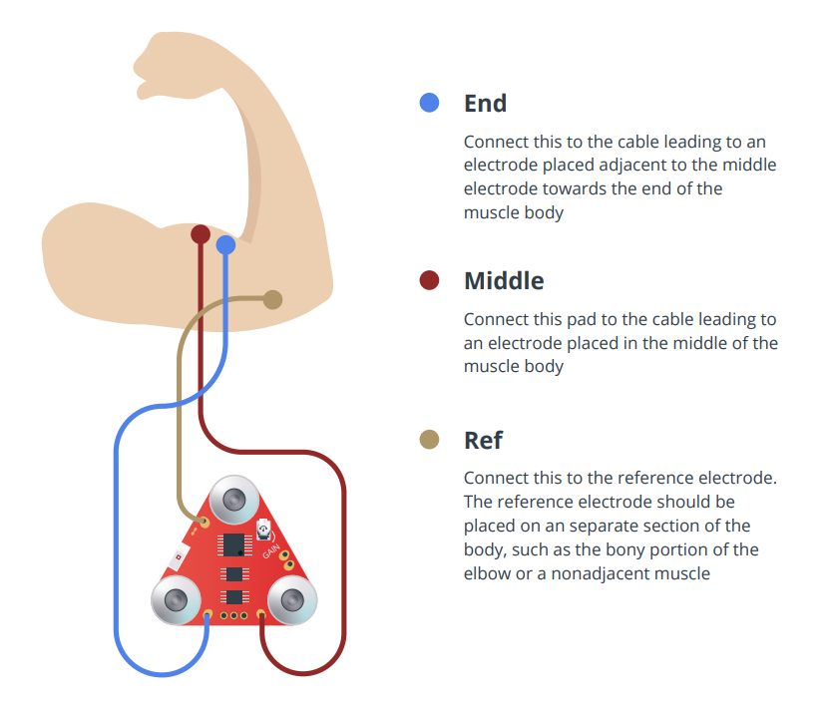

Figure 7 The connection locations of the three electrodes of the EMG sensor, by MyoWare 2.0  QuickStartGuide

The signal after these steps will become the Raw EMG Output, which can be processed by MATLAB [20], also can be processed through High-Pass Filter, Full-Wave Rectifier, diffience Amplifier and Integration Amplifier and get the Envelope EMG Output.

When raw signals are processed with MATLAB,We need to transplant the following functions implemented on hardware to matlab:

1. Put the amplified signal into High-Pass Filter to eliminate the Low frequency signal and potential DC offset to block signals of muscle activity.
2. Use Lead-and-lag rectifier (Precision rectifier) to output the absolute value of the EMG signal.
3. Use differencial amplifier to amplify the difference between the reference electrode and Emg signal after full wave rectifier.
4. Use the Integration Amplifier to get the Envelope EMG Output.

In conclusion, after the EMG signal is measured, the reference signal and the signal at two points of the test electrode are used to amplify and make a difference, rectification, removal of the offset and finally integrated into an EMG envelope signal.

Figure 8 Implementation principle of EMG sensor, reproduced from [24]

However, during the process of the signal collection we need to overcome problems such as the noise, motion artifact and the unstable signal. To encounter the error of the  surface electromyogram signal, we need to take different signal processing technique to get relyable signal.[19]

We use the FFT to analyse the mode of the electromyographic signal and make the signal that should be returned as the expected output (Monitor Mode). Under this mode we can realize the diversification of control modes through using I-channel surface EMG allowing multiple muscles to work together on the drone.[21]

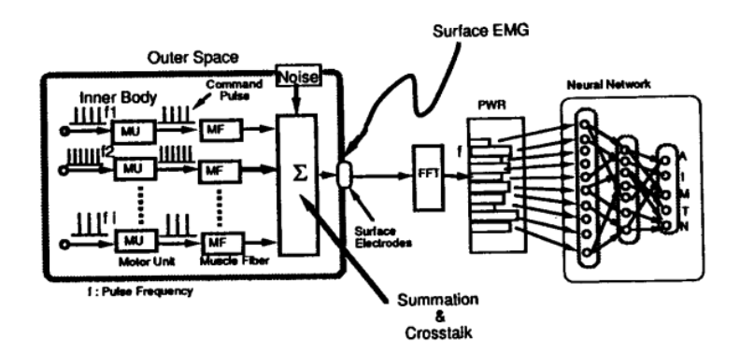

Figure 9 The architecture of using the Neural Network to learn to analyze the muscle movement, reproduced from [21].

During the EMG testing the electromyogram signal, we can also use the Electrical impedance myogram (EIMG) [22] through the Support vector machine (SVM) [24] to obtain the information of the Muscle health. Because when the data set is not large enough, using SVM will be better than neural network and backpropagation algorithm. Observing muscle fatigue and so on to judge the physical health of the operator, which can ensure the safety of the staff. [18][31]

#### 2.3.3.2 Function of UAV(201388759)

Due to topographical changes in irrigation, there are variations between wet and dry areas, leading to uneven water requirements for crop irrigation. Today, several technologies such as ground monitoring stations, wireless sensor networks, satellite imagery, and unmanned aerial vehicle (UAV) imagery are used to monitor the condition of the crops[26]. The use of drones for irrigation requires the integration of positioning, communication, and observation methods to effectively implement this technology.

Drones are remotely operated using an FPV (First-person view) system. A high-definition camera (usually weighing less than 2.5 kg), a video transmitter with a battery, and an FPV system, are installed in the drone. The design control system is improved to enhance time response and dynamic performance, ensuring robust stability. The longitudinal flight of the drone is controlled by a control loop. Drone flight is autonomously managed through multiple PID (proportional-integral-derivative) controllers, with every control module able to use multiple sensors to measure and increase speed and robustness[29].

Our main drones are divided into two types - reconnaissance UAV and irrigation UAV.

The reconnaissance UAV we use is the Phantom 4 Pro Drone (DJI). It is a low-cost drone, with a flight altitude of 500 m and a distance of 5 km from the takeoff point. It has a maximum flight time of 30 minutes, so additional batteries are needed for field surveys. The inbuilt camera has a five-way obstacle sensing system made up of visual and infrared sensors, enabling it to intelligently avoid obstacles during flight[27]. The video recorded during the flight is imported into a GIS database, analysed and a 3D reconstruction of the field is generated. The multispectral  camera on the drone identifies the health of crops[26]. GPS coordinates can be extracted from the gathered images, resulting in a map that provides essential information for the irrigation drone.

The irrigation UAV is primarily a four-wheel-drive drone, equipped with cameras, sensors, and irrigation tools. It defines the location function of the irrigation drone based on the Crop Water Stress Index (CWSI) images derived from the reconnaissance drone. These tracks are a grid network, the speed of the irrigating drone changes according to the crop water stress conditions, achieving precision irrigation in the end[26].

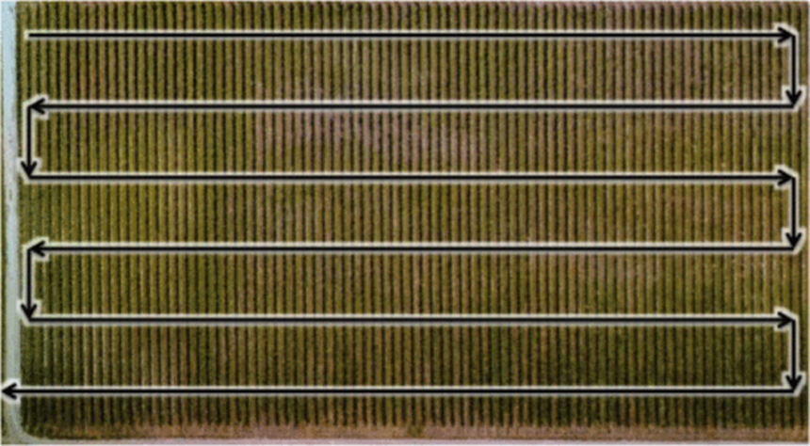

Figure 10 Crop Water Stress Index (CWSI) images, reproduced from [26]

The image of the Crop Water Stress Index (CWSI) [26] Communication between the drone and the operator is made more straightforward to deploy and manage new applications and services, as well as adjusting network policy and performance through a programming method provided by SDN (Software-Defined Networking). OpenFlow is used to offer benefits for mobile and wireless networks, helping optimize resource use in dynamic environments, provide automated operations, allow a finer control level, implement global strategies more easily, and introduce new services more quickly. Also, a mobile management scheme backed by Proxy Mobile IPv6 (PMIPv6) based on WAVE (Wireless Access in Vehicular Environments) is utilized for seamless communication. [30]

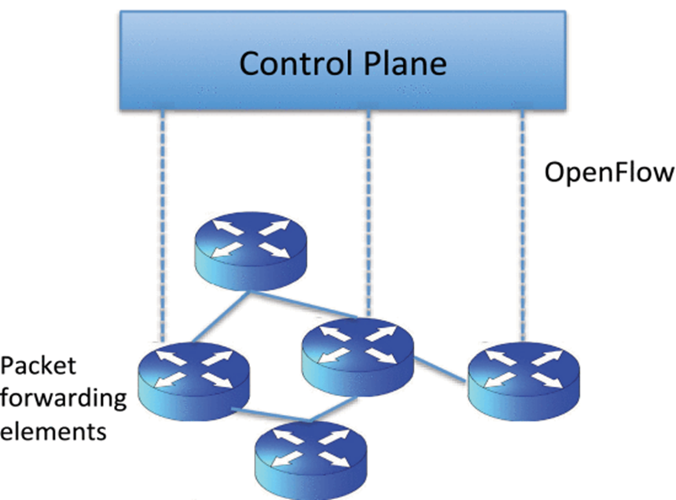

Figure 11 Control Plane of OpenFlow, reproduced from [30]

Reference List

[1 ] UM Rao Mogili, B B V L Deepak,Review on Application of Drone Systems in Precision Agriculture,Procedia Computer Science,Volume 133,2018,Pages 502-509,ISSN 1877-0509

[2 ] Tsouros, D.C.; Bibi, S.; Sarigiannidis, P.G. A Review on UAV-Based Applications for Precision Agriculture. *Information* 2019, *10*, 349.

[3 ] Hopkins, M. The Role of Drone Technology in Sustainable Agriculture.

[4 ] Carolan, M. Publicising Food: Big Data, Precision Agriculture, and Co-Experimental Techniques of Addition: PublicisingFood. Sociol. Ruralis 2017, 57, 135–154.

[5 ] Brisco, B.; Brown, R.J.; Hirose, T.; McNairn, H.; Staenz, K. Precision Agriculture and the Role of Remote Sensing: A Review. Can.J. Remote Sens. 1998, 24, 315–327.

[6 ]L. F. Sanchez, H. Abaunza, and P. Castillo, “Safe navigation control for a quadcopter using user’s arm commands,” International Conference on Unmanned Aircraft Systems (ICUAS) June 13-16, 2017, Miami, FL, USA, 2017.

[7 ] E. M. Weiss, C. G. Kohler, J. Vonbank, E. Stadelmann, G. Kemmler, H. Hinterhuber, et al., "Impairment in emotion recognition abilities in patients with mild cognitive impairment, early and moderate Alzheimer disease compared with healthy comparison subjects," Am J Geriatr Psychiatry, vol. 16, pp. 974-80, Dec 2008.

[8 ] A. I. Meigal, S. Rissanen, M. P. Tarvainen, P. A. Karjalainen, I. A. Iudina-Vassel, O. Airaksinen, et al., "Novel parameters of surface EMG in patients with Parkinson's disease and healthy young and old controls," J Electromyogr Kinesiol, vol. 19, pp. e206-13, Jun 2009.

[9 ] C. DeLuca, R. LeFever, M. McCue, and A. Xenakis, “Behaviour of human motor units in different muscle during linear-varying contractions”, J. Physiol. (London), 329 (1982), pp. 113-128.

[10]Li Peilin. Employment and Institutional Change - The Job Search Process of Two Disadvantaged Groups [M]. Hangzhou: Zhejiang People's Publishing House, 2000.

[11]Zou Bo and Yang Lixiong: The Development of Welfare Enterprises and the Reform of Employment Policies for Persons with Disabilities, People's Publishing House, 2018 Edition, p. 137.

[12]Li Jing, "The Experience and Inspiration of Employment Support for People with Disabilities in the U.S.-Taking Boston as an Example," in Journal of Northwestern University (Philosophy and Social Science Edition), Vol. 49, No. 4, 2019.

[13]FAN Y and YIN Y, "Active and Progressive Exoskeleton Rehabilitation Using Multisource Information Fusion From EMG and Force-Position EPP," in IEEE Transactions onBiomedical Engineering, Dec. 2013, 60(12): 3314-3321.

[14]K. Zimenko, A. Margun and A. Kremlev, "Real-Time Classification for Robotics and HMI", 18th International Conference on Methods & Models in Automation & Robotics (MMAR), 2013.

[15]J. Bolin, J. Hoffman, C. Crawford, S. Beckmann and W. Macke, "Gesture-Based Control of Autonomous UAVs (Extended Abstract)", Proc. of the 16th International Conference on Autonomous Agents and Multiagent Systems (AAMAS 2017), pp. 1484-1486, 2017.

[16]M. T. Wolf, C. Assad, M. T. Vernacchia, J. Fromm and H. L. Jethani, "Gesture-based robot control with variable autonomy from the JPL BioSleeve", 2013 IEEE International Conference on Robotics and Automation, pp. 1160-1165, 2013.

[17]S. Bitzer and P. V. D. Smagt, "Learning EMG control of a robotic hand: Towards Active Prostheses", IEEE International Conference on Robotics and Automation Orlando, 2016.

[18] Hafid, Abdelakram, et al. "EMG & EIMG measurement for Arm & Hand motions using custom made instrumentation based on Raspberry PI." *2020 2nd International Workshop on Human-Centric Smart Environments for Health and Well-being (IHSH)*. IEEE, 2021.

[19]Khan, Sagheer, Kiran Khurshid, and Muhammad Zceshan. "Emg data acquisition and flight control of quadcopter on different emg signals." *2019 14th Iberian Conference on Information Systems and Technologies (CISTI)*. IEEE, 2019.

[20]Mohammed, Noor, Zayed Ahmed, and Raquib-ul Alam. "Design and development of low-cost EMG amplifier for assistive technology." *2017 IEEE International Conference on Power, Control, Signals and Instrumentation Engineering (ICPCSI)*. IEEE, 2017.

[21]Hiraiwa, Akira, Katsunori Shimohara, and Yukio Tokunaga. "EMG pattern analysis and classification by neural network." *Conference proceedings., IEEE international conference on systems, man and cybernetics*. IEEE, 1989.

[22]Hafid, Abdelakram, et al. "EMG & EIMG measurement for Arm & Hand motions using custom made instrumentation based on Raspberry PI." *2020 2nd International Workshop on Human-Centric Smart Environments for Health and Well-being (IHSH)*. IEEE, 2021.

[23]Fontanilla, José A., Jesús D. Urbano, and A. Luque. "Low-cost voltage amplifier for biological signal acquisition through generic micro-electrode array." *2021 13th Spanish Conference on Electron Devices (CDE)*. IEEE, 2021.

[24]Sadikoglu, Fahreddin, Cemal Kavalcioglu, and Berk Dagman. "Electromyogram (EMG) signal detection, classification of EMG signals and diagnosis of neuropathy muscle disease." *Procedia computer science* 120 (2017): 422-429.

[z1] Abdullahi, H.S., Mahieddine, F. and Sheriff, R.E. (2015) ‘Technology impact on agricultural productivity: A review of precision agriculture using unmanned aerial vehicles’, Wireless and Satellite Systems, pp. 388–400. doi:10.1007/978-3-319-25479-1_29.

[26]C. Albornoz and L. F. Giraldo, "Trajectory design for efficient crop irrigation with a UAV," 2017 IEEE 3rd Colombian Conference on Automatic Control (CCAC), Cartagena, Colombia, 2017, pp. 1-6, doi: 10.1109/CCAC.2017.8276401.

[27]Nhamo L, Van Dijk R, Magidi J, Wiberg D, Tshikolomo K. Improving the Accuracy of Remotely Sensed Irrigated Areas Using Post-Classification Enhancement Through UAV Capability. Remote Sensing. 2018; 10(5):712. https://doi.org/10.3390/rs10050712

[z4]Spyridon G. Kontogiannis, John A. Ekaterinaris,Design, performance evaluation and optimization of a UAV,Aerospace Science and Technology,Volume 29, Issue 1,2013,Pages 339-350,ISSN 1270-9638,<https://doi.org/10.1016/j.ast.2013.04.005.>

[29]Anderson, B.D.O., Fidan, B., Yu, C., Walle, D. (2008). UAV Formation Control: Theory and Application. In: Blondel, V.D., Boyd, S.P., Kimura, H. (eds) Recent Advances in Learning and Control. Lecture Notes in Control and Information Sciences, vol 371. Springer, London. <https://doi.org/10.1007/978-1-84800-155-8_2>

[30]L. Gupta, R. Jain and G. Vaszkun, "Survey of Important Issues in UAV Communication Networks," in IEEE Communications Surveys & Tutorials, vol. 18, no. 2, pp. 1123-1152, Secondquarter 2016, doi: 10.1109/COMST.2015.2495297.

[31] Alkan, Ahmet, and Mücahid Günay. "Identification of EMG signals using discriminant analysis and SVM classifier." *Expert systems with Applications* 39.1 (2012): 44-47.